1.
- BOOKWORK (typical easy question, went very well, only those who didn’t study got it wrong).
- [4]
E_{C}
E_{F}
E_{i}
E_{V}
E_{G}
Energy (eV)
- BOOKWORK (with a little twist, seemed to be an easy question)
Use equation from formulae list:
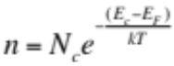
$E_{C}-E_{F}=kTln\left(\frac{N_{C}}{n}\right)=kTln\left(\frac{N_{C}}{N_{D}}\right)=0.026×ln\left(\frac{3.2×{10}^{19}}{2×{10}^{17}}\right)≈0.13 eV$ [2]
$E_{C}-E_{i}=kTln\left(\frac{N_{C}}{n_{i}}\right)=0.026×ln\left(\frac{3.2×{10}^{19}}{1.45×{10}^{10}}\right)≈0.56 eV$ (this is midway the bandgap, as expected for Si) [2]
Since E_{V} = 0 eV, E_{C} = E_{G} = 1.12 eV. [2]
Thus:
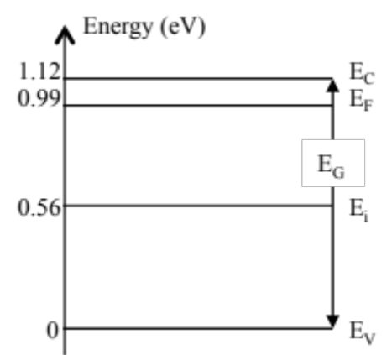. [6]

- BOOKWORK (never asked before. Errors come mainly from not drawing the electric field across the whole x-range where it is non-zero. And errors in calculating the electric field which is really simple)
PE = q V (potential energy = charge × electrostatic potential).
Because: when an electron moves due to an electrostatic potential difference of 1 V, it looses 1 eV of potential energy (definition of an eV).
Thus E_{C}(x=1μm) = E_{C}(x=0 μm) - 1eV × 0.5 V and all lines move the same way.[2] [6]
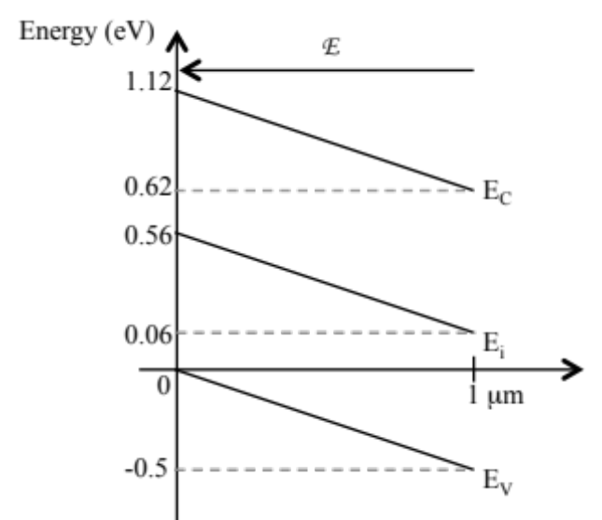[2]
- BOOKWORK
The electric field must point from + to – and thus point “uphill”: electrons loose potential energy whilst drifting through the device.
Use equation:
E $=-\frac{dV}{dx}→$ |E| $=\frac{ΔV}{Δx}=\frac{0.5V}{1μm}=5×{10}^{5}V/m$ [4]

- BOOKWORK(overall question well answered but depletion regions much be consistent with doping) [6]
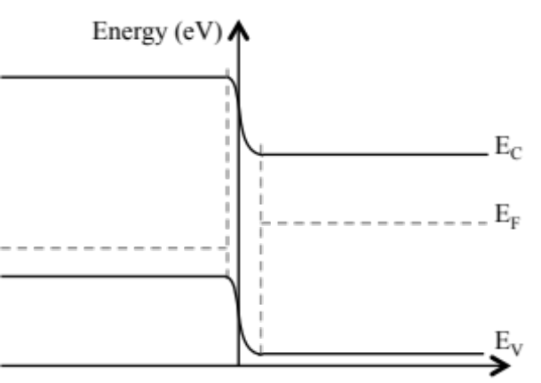
[2] flat PE in neutral regions
[3] correct EF positions + ΔE_{F}
[1] nonlinear EP in depletion region
- BOOKWORK (no problem)
ii1) The pn diode in Fig. 1.2 is FORWARD biased.
ii2) Electrons DIFFUSE from RIGHT TO LEFT across the depletion region.
ii3) Holes DIFFUSE from LEFT TO RIGHT across the n-type region.
ii4) The depletion width in the p-type region is 2 × SMALLER than that in the n-type region. [4]

- BJT - BOOKWORK
- Bias point (1): EB forward and BC reverse
Bias point (2): EB forward and BC forward. [4]

- Holes [2]

- $β=\frac{\left(C\right)+(D)}{\left(B\right)-(D)}$. [4]
Comment: few students realised that |A|=|C| there was also a problem with realising the |B| is not equal to |D|. Answers giving A/B got half the marks, and when stating that this is an approximation, received full marks.

- MOSFET - BOOKWORK
- . [6]
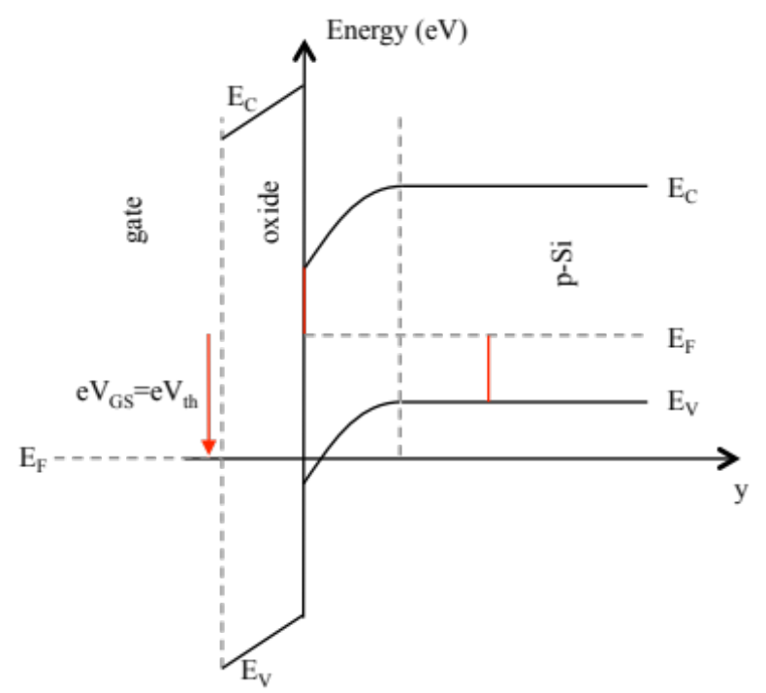
[2] correct distance EP to EF at interface
[2] correct banding
[2] correct EF shift
Comments: the typical error here is to have a different slope across the oxide and the Si or to have the EF of the metal move up rather than down or to use the wrong doping type in the substrate.
- From formulae list. [4]
$I_{DS}= \frac{μC_{ox}W_{g}}{L_{g}}\left[\left(V_{GS}-V_{th}\right)V_{DS}-\frac{V_{DS}^{2}}{2}\right]$
The voltage conditions given mean that the MOSFET is in saturation, thus the current becomes:
$I_{DS}= \frac{μC_{ox}W_{g}}{{2L}_{g}}{\left(V_{GS}-V_{th}\right)}^{2}$
The transconductance is:
$g_{m}=\frac{dI_{DS}}{dV_{GS}}= \frac{μC_{ox}W_{g}}{L_{g}}{\left(V_{GS}-V_{th}\right)}^{}$
Comment: a typical error here is to write IDS saturation as a function of VDS rather than VGS. It is obvious that once this step is taken gm would be zero (derivative!).

2. BJT – different from what was done in lectures and study groups due to varying areas of the different BJT layers. However, due to the statement: “The carrier concentrations and currents are homogeneous in the y-z plane in each layer” this does not make a difference for the majority of the question and only needs to be taken into account when calculating the currents.

A common recurring problem is that units are not given or are wrong. For both, marks are subtracted.

This is the average distance a minority carrier diffuses before it recombines with a majority carrier. [4]
No problem
- From the formulae sheet: $c=c_{0}exp\left(\frac{V}{V_{T}}\right)$ and c₀ must be known by heart: $c_{0}=\frac{n_{i}^{2}}{N}$ with N doping, all minority carrier concentrations at the boundaries can be calculated.
In emitter: $p_{n0E}=\frac{n_{i}^{2}}{N_{D}}=\frac{{\left(1.45×{10}^{10}\right)}^{2}}{5×{10}^{18}}=42{ cm}^{-3}$and ${p^{'}}_{n}=42×exp\left(\frac{0.26}{0.026}\right)≈9×{10}^{5}{ cm}^{-3}$ [2]
In base: $n_{p0}=\frac{n_{i}^{2}}{N_{A}}=\frac{{\left(1.45×{10}^{10}\right)}^{2}}{5×{10}^{16}}=4205{ cm}^{-3}$and ${n^{'}}_{p}=4205×exp\left(\frac{0.26}{0.026}\right)≈9×{10}^{7}{ cm}^{-3}$ and ${n^{"}}_{p}=4205×exp\left(\frac{-1}{0.026}\right)≈8×{10}^{-14}{ cm}^{-3}$ [2]
In collector: $p_{n0C}=\frac{n_{i}^{2}}{N_{D}}=\frac{{\left(1.45×{10}^{10}\right)}^{2}}{1×{10}^{16}}≈2.1×{10}^{4}{ cm}^{-3}$and ${p^{"}}_{n}=2.1×{10}^{4}×exp\left(\frac{-1}{0.026}\right)≈4×{10}^{-13}{ cm}^{-3}$ [2] [6]
Most occurring error is not to have all the required edge concentrations and the other error is to ignore the reverse bias voltage on the BC junction that makes the values low and not equal to the equilibrium values.
- [6]
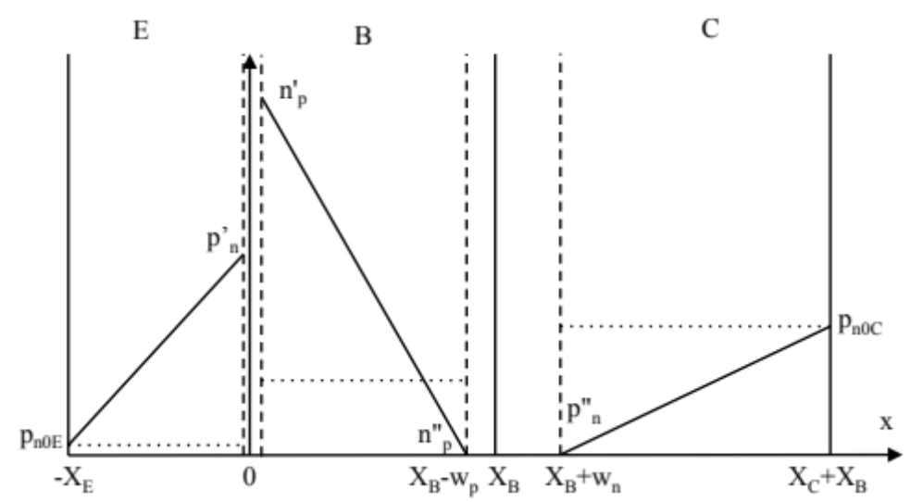
Dashed lines: depletion region edges (both depletion widths taken into account).
Dotted lines: equilibrium minority carrier concentration in each region
w_{p} and w_{n} depletion widths of the reverse biased BC junction
[3] correct differences in carrier concentration position
[2] to depletion region edges
[1] linear variations
Comment: most common problem was plotting the values of the carrier concentrations rather than the excess carrier concentration. Also plotting some lines that are not consistent with the calculations in b) attract a zero mark!
- The easiest way is to use the above figure to calculate the currents. We will neglect the leakage current across the BC junction as the BJT is operating in forward active mode. The emitter current is the EB diode current, the collector current is the electron current component in the emitter current. Units for the calculations will be cm.
First however we need to calculate the depletion width w_{p}. We do not need w_{n} because we are neglecting the reverse bias BC junction leakage. We can use the equations given in the formulae sheet.
The built-in voltage [9]
$V_{bi}=V_{T}ln\left(\frac{N_{A}N_{D}}{n_{i}^{2}}\right)=0.026ln\left(\frac{5×{10}^{16}×{10}^{16}}{{\left(1.45×{10}^{10}\right)}_{}^{2}}\right)=0.74 V$ [1]
p-region depletion width:
$w_{p}\left(V\right)={\left[\frac{2ϵ_{0}ε_{Si}\left(V_{bi}-V\right)N_{D}}{e\left(N_{A}+N_{D}\right)N_{A}}\right]}^{\frac{1}{2}}={\left[\frac{2×8.85×{10}^{-14}×11×\left(0.74+1\right){10}^{16}}{1.6×{10}^{-19}×\left(5×{10}^{16}+{10}^{16}\right)×5×{10}^{16}}\right]}^{\frac{1}{2}}=8.4×{10}^{-6}cm=8.4×{10}^{-6}\left({10}^{4}μm\right)$ $=8.4×{10}^{-2}μm$ [2]
Magnitude of emitter current: [4]
$$I_{E}=I_{p}+I_{n}=eA_{E}D_{E}\frac{Δp_{nE}}{X_{E}}+eA_{B}D_{B}\frac{Δn_{pB}}{X_{B}-w_{p}}=1.6×{10}^{-19}\left(40×40\right){\left(μm\right)}^{2}4\frac{9×{10}^{5}}{0.4μm}+1.6×{10}^{-19}\left(50×50\right){\left(μm\right)}^{2}20\frac{9×{10}^{7}}{\left(0.8-8.4×{10}^{-2}\right)μm}$$
convert μm into cm
$$I_{E}=1.6×{10}^{-19}\left(40×40\right){\left({10}^{-4}cm\right)}^{2}4\frac{9×{10}^{5}}{0.4\left({10}^{-4}cm\right)}+1.6×{10}^{-19}\left(50×50\right){\left({10}^{-4}cm\right)}^{2}20\frac{9×{10}^{7}}{\left(0.8-8.4×{10}^{-2}\right)\left({10}^{-4}cm\right)}$$
I_{E} = 2.3 10⁻¹³ A + 10⁻¹⁰ A [2]
I_{C} = 10⁻¹⁰ A
I_{B} = 2.3 10⁻¹³ A
Comment: a lot a students lost a lot of time on this questions by taking the diode equations from the formulae sheet and recalculating effectively everything that was already calculated in b). Then of course there was no time to deal with the depletion width. Thus marks went to those students who realised that currents are determined by the gradients as in the solution above.

3. MOSFET – different from what was done in the lectures due to existence of a workfunction difference. The influence of workfunction difference was explained for the energy band diagram in the study groups but was not connected to a change in the capacitance voltage characteristics.

- The mobility is inversely proportional to the mass of the carriers. The mass of electrons in Si is lower than that of holes and thus electron mobility is higher. [4]
Most had this correct.
- When φ_{G} > φ_{p} then the MOSFET is in accumulation. [6]
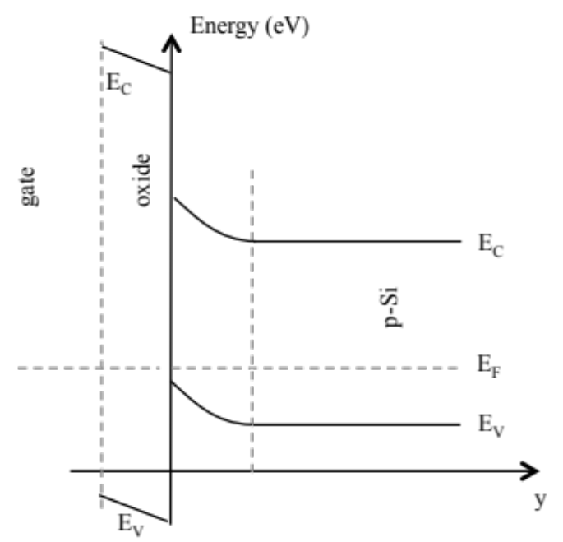
[2] correct distance EP to EF at interface
[2] correct banding
[2] correct EF shift
Few had the bending right.
- V_{GS} < 0 the MOSFET is in accumulation (increase hole density underneath oxide). [2]
C_{GS} is maximum and it value is determined by the oxide thickness. [9]
0 < V_{GS} < V_{FB} the MOSFET is still in accumulation until the energy bands flatten at V_{GS} = V_{FB} = φ_{G} > φ_{p} [2]
V_{FB} < V_{GS} < V_{th} a depletion region is building up underneath the gate oxide. C_{GS} is decreasing until the depletion width has reached a maximum value at V_{GS} = V_{th} when an inversion channel is created. C_{GS} is minimum for V_{GS} ≥ V_{th}. [2]
The main remark here is that in general the answer described the plot rather than explain why the plot looked the way it did, thus explain the origin of the variations rather than say “it varies”.
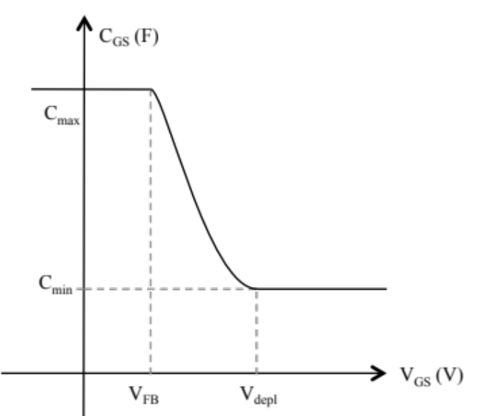[3]
- C_{max} = ½ C_{ox} L_{g} W_{g} = ½ ε_{ox} ε₀ L_{g} W_{g}/t_{ox} [6]
All parameters expressed in cm
C_{max} = ½ 4 8  2 10⁻⁴ 5 10⁻⁴/(10 10⁻⁷) = 1.77 10⁻¹⁴ F [2]

C_{min} = C_{max}//C_{depl} (parallel connection)
The depletion capacitance is associated with the maximum depletion width. The formula is given in the formulae list.
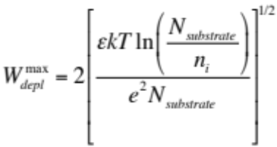
$W_{depl}^{max}=2{\left[\frac{11×8.85×{10}^{-14}×0.026×ln\left(\frac{5×{10}^{16}}{1.45×{10}^{10}}\right)}{1.6×{10}^{-19}×5×{10}^{16}}\right]}^{1/2}=1.38×{10}^{-5}cm$ [2]
$C_{depl}=\frac{ϵ_{0}ϵ_{Si}A}{W_{depl}^{max}}=\frac{11×8.85×{10}^{-14}×2×{10}^{-4}5×{10}^{-4}}{1.38×{10}^{-5}}=5×{10}^{-15}F$
$\frac{1}{C_{min}}=\frac{1}{C_{max}}+\frac{1}{C_{depl}}=\frac{C_{depl}+C_{max}}{C_{max}C_{depl}}$ [2]
$C_{min}=\frac{C_{max}C_{depl}}{C_{depl}+C_{max}}=\frac{1.77×{10}^{-14}×5×{10}^{-15}}{1.77×{10}^{-14}+5×{10}^{-15}}=3.9×{10}^{-15} F$
Note: no-one remembered the factor ½ in C_{max} = ½ C_{ox} L_{g} W_{g} which is a result of the MOSFET being in the triode region! In the end more marks were taken off. Can the student cohort remember this factor ½ for the future – analogue electronics.

